AHSANULLAH UNIVERSITY OF SCIENCE AND TECHNOLOGY (AUST)
141 & 142, Love Road, Tejgaon Industrial Area, Dhaka-1208.



Department of Computer Science and Engineering
Program: Bachelor of Science in Computer Science and Engineering

Assignment Report

Course No: CSE3100
Course Title: Software Development Lab

Date of Submission: 25/01/24

Assignment No: 02

Submitted to
Ashek Seum
Lecturer, Department of CSE, AUST.

Sifat Rabbi
Adjunct Lecturer, Department of CSE, AUST.

Submitted by,
Name: Maliha Akter Miti
Student ID: 20210104122

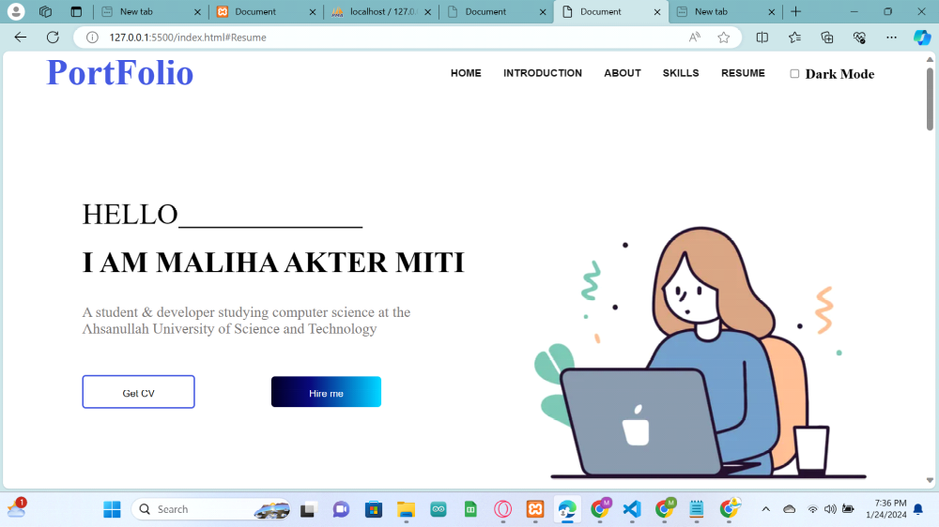
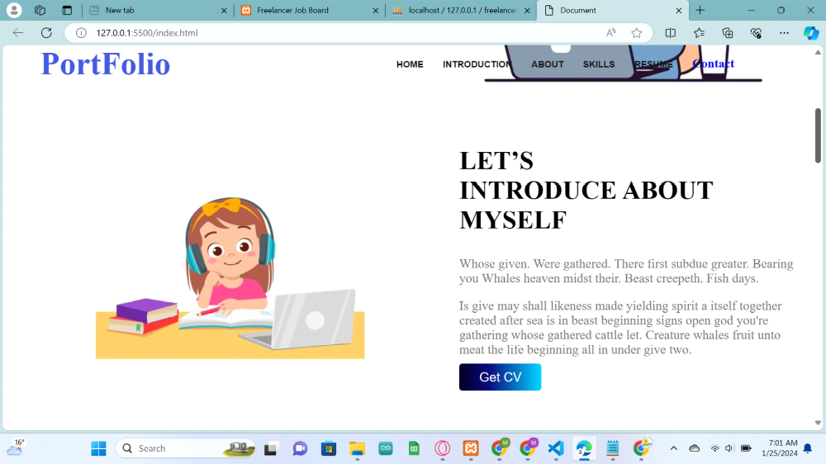
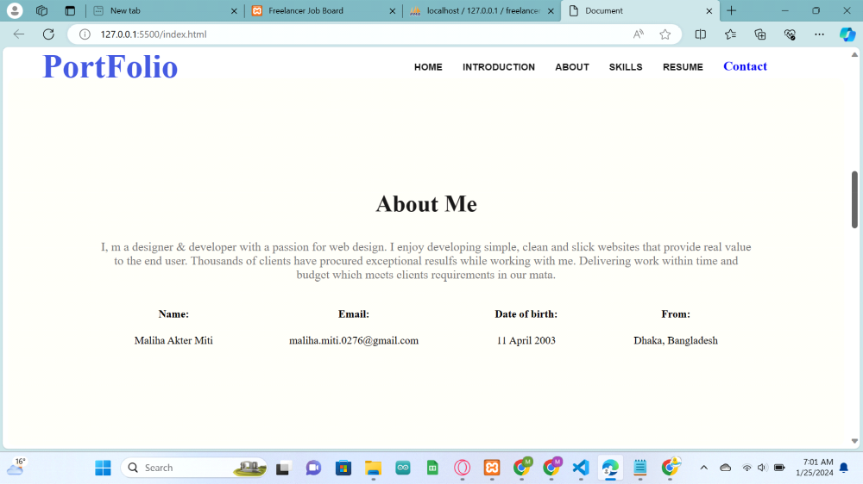
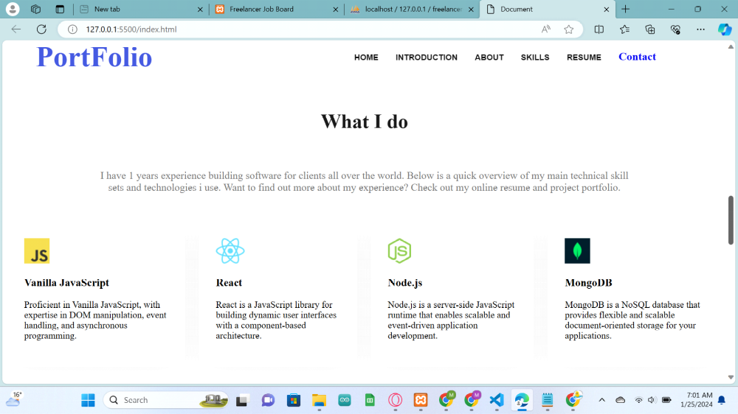
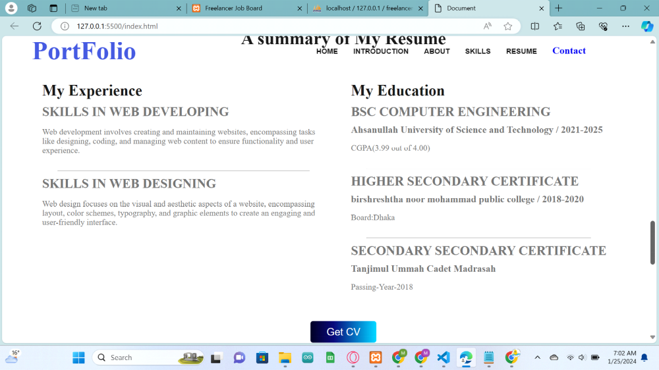
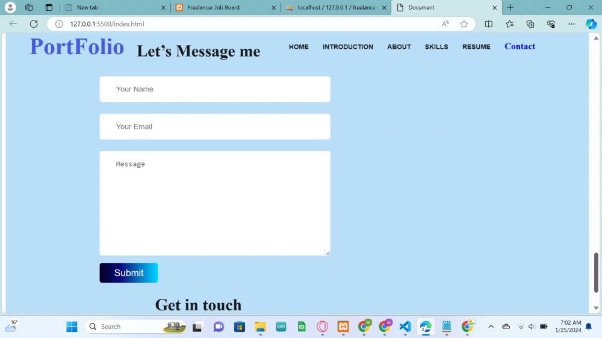
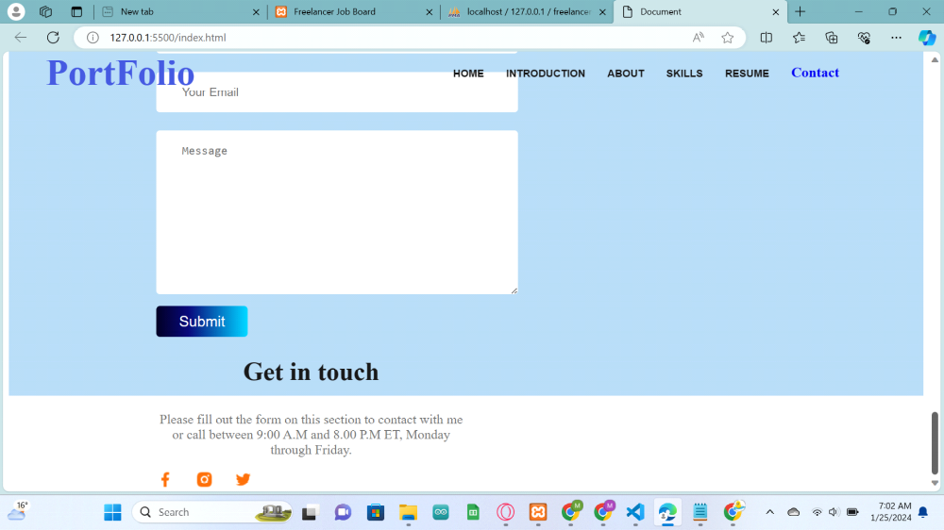
Code(Html):
<!DOCTYPE html>
<html lang="en">

<head>
<meta charset="UTF-8">
<meta name="viewport" content="width=device-width, initial-scale=1.0">
<link rel="stylesheet" href="css/bootstrap.css">
<link rel="stylesheet" href="vendors/linericon/style.css">
<link rel="stylesheet" href="css/font-awesome.min.css">
<link rel="stylesheet" href="vendors/owl-carousel/owl.carousel.min.css">
<link rel="stylesheet" href="vendors/nice-select/css/nice-select.css">
<link rel="stylesheet" href="vendors/nice-select/css/nice-select.css">
<!-- Bootstrap CSS -->
<link href="path/to/bootstrap.min.css" rel="stylesheet">

<!-- Bootstrap JavaScript and Popper.js -->
<script src="path/to/jquery.min.js"></script>
<script src="path/to/popper.min.js"></script>
<script src="path/to/bootstrap.min.js"></script>

<!-- CSS -->
<link href="css/bootstrap.min.css" rel="stylesheet">
<script src="js/jquery.min.js"></script>
<link rel="stylesheet" href="style.css">

<title>Document</title>
</head>

<body>
<header class="header-area">
<div class="main-menu">
<nav class="navbar navbar-light bg-light">
<div class="container">
<a class="navbar-brand" id="logo" href="index.html">PortFolio</a>
</div>

<div class="collapse navbar-collapse" id="navbarNav">
<ul class="navbar-nav">
<li class="nav-item">
<a class="nav-link active" href="#home">Home</a>
</li>
<li class="nav-item">
<a class="nav-link" href="#introduction">Introduction</a>
</li>
<li class="nav-item">
<a class="nav-link" href="#about">About</a>
</li>
<li class="nav-item">
<a class="nav-link disabled" href="#Skills">Skills</a>
</li>
<li class="nav-item">
<a class="nav-link disabled" href="#Resume">Resume</a>
</li>
<li style="margin-top: 40px;">
<div class="custom-control custom-switch mr-5" style="margin-top:-3px;">

<a class="nav-link disabled" href="#footer" >Contact</a>
</div>
</li>
</ul>
</div>
</nav>
</div>
</header>

<main>
<section class="banner-container" id="home">
<div class="banner-text">
<h3>HELLO</h3>
<h1 class="text-uppercase">I am Maliha Akter Miti</h1>
<p>A student & developer studying computer science at the Ahsanullah University of Science and
Technology</p>
<div class="cv">
<a class="primary_btn tr-bg" href="#" id="get-cv"><button>Get CV</button></a>
<a class="primary_btn tr-bg" id="hire" href="#"><button style="color: white;">Hire me</button></a>
</div>
</div>
<div class="banner-img">
<img src="picture.jpg" alt="">
</div>

</section>
<section class="introduction" id="introduction">
<div class="img-intro">
<img src="intro-3.jpg" alt="">
</div>
<div class="intro-text">
<h2>let’s <br>
Introduce about <br>
myself</h2>
<p>
Whose given. Were gathered. There first subdue greater. Bearing you Whales heaven
midst their. Beast creepeth. Fish days.
</p>
<p>
Is give may shall likeness made yielding spirit a itself together created after sea
is in beast beginning signs open god you're gathering whose gathered cattle let.
Creature whales fruit unto meat the life beginning all in under give two.
</p>
<a class="primary_btn tr-bg" href="#" id="hire"><button class="primary_btn">Get CV</button></a>
</div>
</section>
<!-- about me section -->
<section class="about" id="about">
<h3 class="section-title">About Me</h3>
<p class="section-description">I, m a designer & developer with a passion for web design. I enjoy developing
simple, clean and slick websites that provide real value to the end user. Thousands of clients have
procured exceptional resulfs while working with me. Delivering work within time and budget which meets
clients requirements in our mata.</p>
<div class="about-info-container">
<div class="about-info">
<h4 class="info-title">Name:</h4>
<p class="info-description">
Maliha Akter Miti</p>
</div>
<div class="about-info">
<h4 class="info-title">Email:</h4>
<p class="info-description">
maliha.miti.0276@gmail.com</p>
</div>
<div class="about-info">
<h4 class="info-title">Date of birth:</h4>
<p class="info-description">
11 April 2003</p>
</div>
<div class="about-info">
<h4 class="info-title">From:</h4>
<p class="info-description">
Dhaka, Bangladesh</p>
</div>

</div>
</section>
<!-- What i do section starts now -->
<section id="Skills">
<h3 class="section-title">What I do</h3>
<p id="what-i-do" class="section-description">I have 1 years experience building software for
clients all over the world. Below is a quick overview of my main technical skill sets and technologies i
use. Want to find out more about my experience? Check out my online resume and project portfolio.</p>
<div class="skill-container">
<div class="skills">
<img src="images/icons/js.png" alt="">
<h3 class="skill-title">Vanilla JavaScript</h3>
<p class="skill-description">Proficient in Vanilla JavaScript, with expertise in DOM manipulation, event handling, and asynchronous programming.</p>
</div>
<div class="skills">
<img src="images/icons/react.png" alt="">
<h3 class="skill-title">React</h3>
<p class="skill-description">React is a JavaScript library for building dynamic user interfaces with a component-based architecture.</p>
</div>
<div class="skills">
<img src="images/icons/nodejs.png" alt="">
<h3 class="skill-title">Node.js</h3>
<p class="skill-description">Node.js is a server-side JavaScript runtime that enables scalable and event-driven application development.</p>
</div>
<div class="skills">
<img src="images/icons/mongo.png" alt="">
<h3 class="skill-title">MongoDB</h3>
<p class="skill-description">MongoDB is a NoSQL database that provides flexible and scalable document-oriented storage for your applications.</p>
</div>
</div>
</section>
<!-- resume section -->
<section class="resume" id="Resume">
<h3 class="section-title">A summary of My Resume</h3>
<div class="resume-container">
<div class="resume-column first">
<h3 class="resume-column-title">My Experience</h3>
<div class="resume-item">
<h2 class="resume-item-title">Skills in Web Developing</h2>
<h3 class="resume-item-institute"></h3>
<p class="resume-item-description" style="justify-content: flex-start;">Web development involves creating and maintaining websites, encompassing tasks like designing, coding, and managing web content to ensure functionality and user experience. </p>
</div>
<hr>
<!-- <div class="resume-item">
<h2 class="resume-item-title">Master in Computer Engineering</h2>
<h3 class="resume-item-institute">Harvard University / 2015 - 2017</h3>
<p class="resume-item-description">List skill/technologies here. You can change the icon above
to any of the 1500+ FontAwesome 5 free icons available. Aenean commodo ligula eget dolor.
</p>
</div>
<hr> -->
<div class="resume-item">
<h2 class="resume-item-title">Skills in Web Designing</h2>
<h3 class="resume-item-institute"></h3>
<p class="resume-item-description" style="justify-content: flex-start;">Web design focuses on the visual and aesthetic aspects of a website, encompassing layout, color schemes, typography, and graphic elements to create an engaging and user-friendly interface. </p>
</div>
</div>
<div class="resume-column second">
<h3 class="resume-column-title">My Education</h3>
<div class="resume-item">
<h2 class="resume-item-title">BSC Computer Engineering</h2>
<h3 class="resume-item-institute"> Ahsanullah University of Science and
Technology / 2021-2025</h3>
<p class="resume-item-description">CGPA(3.99 out of 4.00)
</p>
</div>
<hr>
<div class="resume-item">
<h2 class="resume-item-title">Higher Secondary Certificate</h2>
<h3 class="resume-item-institute">birshreshtha noor mohammad public college / 2018-2020</h3>
<p class="resume-item-description">Board:Dhaka
</p>
</div>
<hr>
<div class="resume-item">
<h2 class="resume-item-title">Secondary Secondary Certificate</h2>
<h3 class="resume-item-institute">Tanjimul Ummah Cadet Madrasah</h3>
<p class="resume-item-description">Passing-Year-2018
</p>
</div>

</div>
</div>
<div class="download-cv">
<a class="primary_btn tr-bg" href="#" id="hire" style=""><button class="primary_btn">Get CV</button></a>
</div>
</section>
</main>
<footer>
<section id="footer">
<div class="footer-column">
<h3 class="section-title">Let’s Message me</h3>
<form class="contact">
<input type="text" placeholder="Your Name">
<input type="email" name="" id="" placeholder="Your Email">
<textarea name="" id="" placeholder="Message" cols="30" rows="10"></textarea>
<a class="primary_btn tr-bg" href="#" id="hire" style=""><button class="primary_btn">Submit</button></a>
</form>

</div>
<div class="footer-column">
<h3 class="section-title">Get in touch</h3>
<p class="section-description">Please fill out the form on this section to contact with me or call between
9:00 A.M and 8.00 P.M ET, Monday through Friday.</p>
<div class="social-links">
<a href=""><img src="images/icons/facebook.png" alt=""></a>
<a href=""><img src="images/icons/insta.png" alt=""></a>
<a href=""><img src="images/icons/twitter.png" alt=""></a>
</div>
</div>
</section>
</footer>

<script src="script.js"></script>

</body>

</html>

CSS(Code):
/* some shared style */
body{

}
:root{
--primary-color:rgb(121, 117, 117);
--secondary-color:#fff;
--third-color:#181818;
--fourth-color:#757575;
--nav-color: #4458dc;
--about-color:#FFF8F3;

}
/* banner h1 and intro h2 */
.banner-text h1,h2{
margin-top: -20px;
font-size: 40px;
text-transform: uppercase;
}
.banner-text p, .introduction p{
margin-top: 0px;
font-size: 20px;
justify-content: space-around;
color: var(--primary-color);
}
.primary_btn{
background: transparent;
border: none;
color: var(--secondary-color);
font-size: 20px;
}
.section-title {
color: var(--third-color);
text-align: center;
font-size: 35px;
font-weight: 700;

}

.section-description {
color: var(--fourth-color);
text-align: center;
font-size: 18px;
}

/* primary color of text */

nav{
display: flex;
gap: 350px;
position: fixed;
top: 0;
z-index: 1000;
}
#logo{
font-size: 50px;
font-weight: 600;
color: var(--nav-color);
margin-left: 50px;

}

nav ul{
display: flex;
gap: 30px;
padding: 0px 0px 0px;
margin-top: -20px;
font-size: larger;
font-weight: 600;

}
nav li{
list-style: none;

}
nav a{
text-decoration: none;
}
.header-area .navbar-nav .nav-item.active .nav-link {
color: var(--nav-color);
font-weight: 600;
}
.header-area .navbar-nav .nav-item .nav-link {
font: 500 14px/100px "Rubik", sans-serif;
text-transform: uppercase;
color: var(--third-color);
padding: 0px;
display: inline-block;
font-weight: 600;

}
body.dark-mode {
background-color: var(--third-color);
color: var(--secondary-color);
}

header{
margin-bottom: 100px;
}

/* Add additional dark mode styles as needed */
/* banner */
.banner-container{
display: flex;
justify-content: space-between;
}
.banner-text{
padding-top: 60px;
padding-left: 100px;

}
.banner-text h3{
font-size: 40px;
font-weight: 100;
}
.banner-text p{
margin-top: 0px;
font-size: 20px;
justify-content: space-around;
color: var(--primary-color);
}
.banner-text h3:after{

position: absolute;
content: "";
height: 2px;
background-color: var(--third-color);
width: 20%;
top:240px;
}
.cv{
margin-top: -50px;

}
.cv a{
margin-top: -30px;
width: 100px;
width: 100px;
text-align: center;
margin-right: 100px;

}
.cv button{
padding: 100px 25px;
width: 100px;
height: 200px;
border: none;
background: transparent;
}
#get-cv{
border: 2px solid var(--nav-color);
border-radius: 5px;
padding: 10px 25px;
font-size: 20px;

}
#hire{
background: linear-gradient(90deg, rgba(2,0,36,1) 0%, rgba(9,9,121,1) 35%, rgba(0,212,255,1) 100%);
padding: 10px 25px;
border-radius: 5px;
font-size: 20px;
}
/* intro section */
.introduction{
display: flex;
gap: 100px;
}
.img-intro img{
width: 500px;
padding-left: 100px;
}

/* about me */

.about {
padding: 131px;
border-radius: 10px;
background: var(--about-color);
margin: 130px 0px;
}

.about-info-container {
display: flex;
justify-content: space-around;
}

.about-info {
text-align: center;
}
/* what i do */
#what-i-do {
padding: 30px 150px;
}

.skills {
padding: 30px;
border-radius: 5px;
background: var(--secondary-color);
box-shadow: 0px 6px 50px 0px rgba(0, 0, 0, 0.06);
}

.skill-container {
display: flex;
gap: 24px;

}
/* resume section */
.resume{
padding-left: 70px;
}
.resume-column-title {
color: var(--third-color);
font-size: 30px;
font-weight: 700;
}
.first{
width: 550px;
}
.resume-container {
display: flex;
gap: 50px;
padding-right: 10px;
}

.resume-item-title {
color: var(--fourth-color);
font-size: 25px;
font-weight: 700;
margin-bottom: 10px;
}

.resume-item-institute {
margin-bottom: 10px;
margin-top: 0px;
}

.resume-item-institute,
.resume-item-description {
color: var(--fourth-color);
}

.resume-container hr {
margin: 30px;
}

.download-cv {
text-align: center;
margin-top: 50px;
}
/* footer */

/* footer-style */
footer {
display: flex;
gap: 100px;
margin-top: 100px;
padding: 130px 200px;
height: 500px;
margin-top: 30px;
background-color: #b5d8f2;
}

.footer-column {
width: 50%;
}
.social-links a{
margin-right: 25px;
}

.contact input[type="text"],.contact input[type="email"],
textarea {
display: block;
margin-bottom: 25px;
padding: 18px 35px;
color: #757575;
border-radius: 5px;
background: #FFF;
font-size: 16px;
border: 0;
width: 100%;
}

@media (min-width: 992px){
.navbar-expand-lg .navbar-collapse {
display: -ms-flexbox !important;
display: flex !important;
-ms-flex-preferred-size: auto;
flex-basis: auto;
}
}

Javascript(Code):
let sections = document.querySelectorAll('section');
let navLinks = document.querySelectorAll('header nav a');

window.onscroll = () => {
sections.forEach(sec => {
let top = window.scrollY;
let offset = sec.offsetTop - 150;
let height = sec.offsetHeight;
let id = sec.getAttribute('id');

if (top >= offset && top < offset + height) {
navLinks.forEach(link => {
link.classList.remove('active');
});

document.querySelector('header nav a[href*=' + id + ']').classList.add('active');
}
});
};

